Cheshire Cricket Board Club Audit: Season 2020 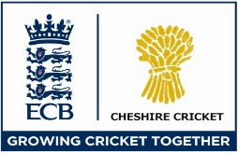
Number of Players | Boys | Girls | Comments
All Stars
Under 7s / Year 2
Under 8s / Year 3
Under 9s / Year 4
Under 10s / Year 5
Under 11s / Year 6
Under 12s / Year 7
Under 13s / Year 8
Under 14s / Year 9
Under 15s / Year 10
Under 16s / Year 11
Under 17s / Year 12
Under 18s / Year 13
Under 19s
Senior Men
Senior Women
Number of Teams | Boys | Girls | Comments – Please note if the team did not play any fixtures due to Covid
Under 7s
Under 8s
Under 9s
Under 10s
Under 11s
Under 12s
Under 13s
Under 14s
Under 15s
Under 16s
Under 17s
Under 18s
Under 19s
Seniors
Number of Volunteers | Male | Female | Comments
Active coaches
Coach Support workers
All Stars Activators
All Stars Junior Activators
Parent helpers
Umpires
Scorers
Ground staff

